A RHYTHMIC RE-BARRING OF
PAUL CRESTON’S CONCERTO FOR ALTO SAXOPHONE AND ORCHESTRA

Chandler Hertz
Music Theory IV
12/11/2015

Paul Creston’s Concerto for Alto Saxophone Op. 26 was written in 1941. Creston’s style of composing involved a strong rhythmic drive and use of multi-meter techniques. Within his use of rhythmic techniques, he used a system of notation which made all measures consistent in number of beats. The first movement of his Concerto for Alto Saxophone is written in three. While writing with a consistent time signature, Creston creates a feeling of mixed meter through the use of various techniques: accent placement, slur placement and duration, melodic movement, harmonic motion, harmonic density, and rhythmic complexity.
Rhythmic re-barring is a system of using notational cues to uncover the underlying stylistic nuances in a piece of music. Throughout styles such as primitivism and a portion of neo-classicism, composers favored rhythmic variation and influence. However, in this time of early exploration in the use of irregular and mixed meter, there was some discrepancy concerning its use in most writing. Paul Creston still favored the use of a single meter rather than mixed meter. Instead he uses accents, slurs, melodic lines, and hemiolas to create the illusion of mixed meters. This analysis and re-barring of Creston’s Concerto for Alto Saxophone and Orchestra exists to provide the soloist with an understanding of the rhythmic elements used to create this piece and help formulate a new structure that proves to help the soloist in exploring the many rhythmic variations throughout. A complete re-barring is included at the end of this analysis, but the content of this analysis will focus on portions of the first movement and specific sections that seem unclear at a first look.
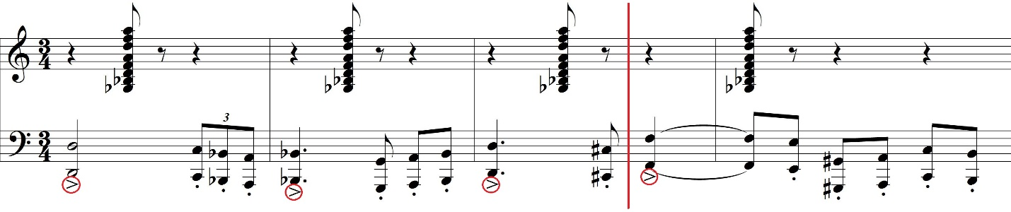
Throughout the first section, accents were used as cues to find the underlying framework for the new bar lines. Figure 1.1 shows an example from the opening measures of the Creston Concerto. All accents have been circled and figured as beat one of their respective measures. In this example, most accented beats line up, although the bar line succeeding measure 3 has been moved up one beat to follow the frame set by the accents.

The orchestra follows the pattern showed in Figure 1.1 throughout the opening. The next major event occurs when the soloist enters. Throughout the entire first movement, the soloist plays two short cadenzas. Both are found at the beginning with the orchestra playing the opening theme between each of the cadenzas. Both cadenzas are quite similar in both structure and direction. One of the main differences between the two is the starting beat. The first cadenza begins on beat three with a fermata while the second cadenza begins on beat one with a fermata. By re-barring the opening measures, both cadenzas can be shifted to start on beat one. However, when this is done, the first cadenza becomes impossible to format into a common meter. Since both cadenzas are compiled entirely of sixteenth notes with the exception of the opening note, there is no visual cue to discern any specific meter during those measures. To fix this issue, it can be assumed that, since notes with fermatas have theoretically no given duration or beat value, they can be ignored as having the beat duration assigned in the original score. Both cadenzas begin with quarter notes tied to an eighth note. The fermata rests above the quarter note in both instances. Rhythmically, the note could theoretically have the same duration and value is there was only an eighth note with the fermata. By hypothetically dropping the quarter note off of the first cadenza, it is possible to group all of the sixteenth notes by general direction to create the new bar lines for each cadenza.
Figure 1.2 shows the soloist’s first introduction of the second theme. During the second theme, a combination of both accents and slurs as visual cues uncovered a shift in pulse from the quarter note to the dotted quarter note. Creston plays on this shift throughout the entire section, moving back and forth between his original notation in three and a new feeling in two. Notice how each measure in the following excerpt reveals a different relationship between three and two.

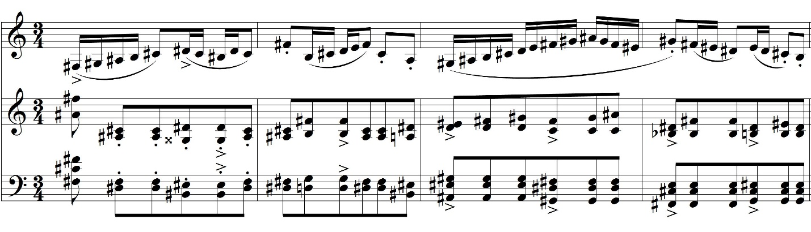
The first measure of Figure 1.2 shows a division of two in the solo saxophone part. The accents are placed on beat one and the off-beat of beat two. The two portions are then outlined with slurs to bring out the new pulse. Also in measure one of Figure 1.2, the orchestra has an accent placed on beat three. Beat one can also be discerned as accented because of its higher range and thicker chordal structure. In this first measure, Creston opens with a feeling of three against two. For clarity reasons, whenever instances such as this occurred, the soloist’s rhythmic structure was always chosen for the final re-barring.
The second measure shows an agreement between the two musical ideas. The orchestra is the first to set up an idea for pulse with its accent on beat two. The saxophone then answers with two articulate eight notes creating a structure in three for this measure. The same agreement can be found in the fourth bar. This time, both parties agree on a structure of two.
The third bar was treated a bit differently. Since the soloist has running sixteenth notes, there is no real sense of pulse. This is the same issue that occurred on a larger scale with the cadenza. Fortunately, this time the orchestra is present and shows a strong pulse on beat one and the off-beat of beat two. This measure is also felt in two. Patterns such as these can be found throughout the entire B section of the Concerto’s first movement.
As this section comes to a close, the orchestra once again returns to the opening theme. This time, when the soloist enters, a slow build begins. The soloist enters with a version of the melody from the A section and the orchestra becomes much thinner. This melody continues to build over the next pages of the movement. Figure 1.3 shows the dynamic and rhythmic climax of the entire first movement.
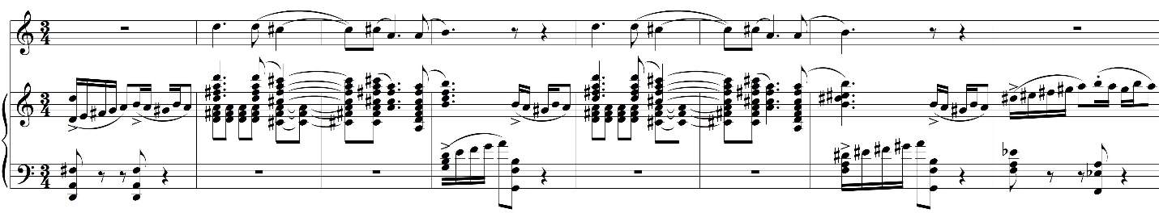
The first, fourth, seventh, and eighth measures of Figure 1.3 consist of material from the B section. These measures all consist of three beats in a structure of two based off of the dotted quarter note. Measures two, three, five, and six all consist of material from the A section. Referring back to the A section, Creston uses the relationship between the dotted quarter note and the following eighth note(s) to form a melody in the measures. In these bars, Creston uses the same hemiola repeatedly to create a structure in two. The quarter note is used as the main pulse in these measures rather than the dotted quarter notes in the previously discussed measures. In this instance, Creston creates two contrasting ideas, both of which are in two, to create one musical line. The relationship between these two structures is the amount of actual space they take. While both themes are created in the structure of two, the theme from the B section actually takes up the space of three beats while the theme from the A section only takes up the space of two beats. This is significant because it enforces the relationships between all of the rhythmic patterns Creston uses throughout the entire work in just a few measures. It also outlines the importance of the dotted quarter note as an integral value of the composition.
The coda section lasts for three pages, and contrary to the rest of the work, is fairly straightforward in design. The odd detail about the coda is that is sounds entirely different compared to the rest of the work. The coda fits Creston’s original meter in structure. The soloist enters with rising figures several times. Over the duration of the coda, the starting beat of the rising figures changes. Originally, it could have been stated that the rising figures indicate the meter. This would alter the form and make re-barring necessary to see the structure. In this case, it was unnecessary to re-bar the coda due to the orchestra’s accompaniment. From the opening measure of the coda, the orchestra has the same repeated rhythm throughout the coda. This creates a strong grounding for the rhythmic pulse. Due to the orchestra, it doesn’t matter that the soloist shifts the beats around. With a strong rhythmic pulse underneath the rising figures, the beat stays solid and doesn’t require extra attention to discern. The only straying from this occurs in the final measures of the movement when the orchestra returns to a structure in two to tie the composition together and end in a grand major chord.

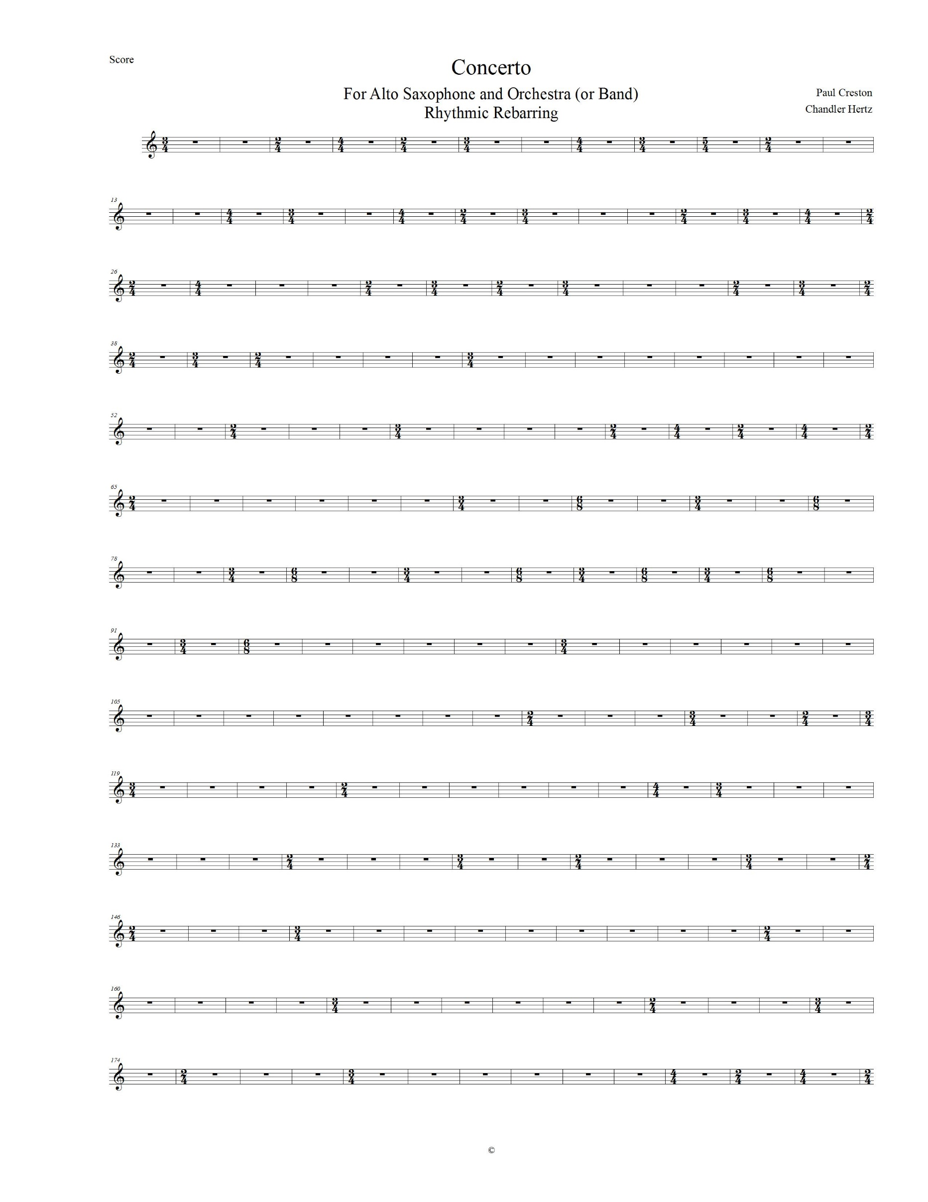
Figure 1.1

Figure 1.2

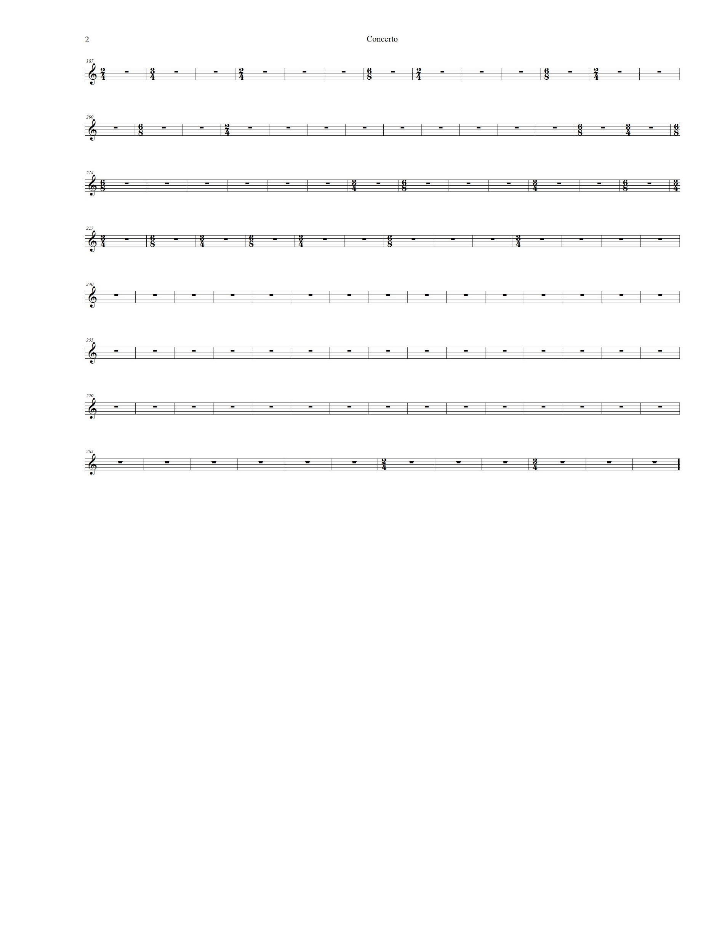
Figure 1.3

Bibliography

“Creston, Paul (10/10/1906-8/24/1985)” Naxos Music Library, naxosmusiclibrary.com/composer/btm.asp?composerid=22406

Paul Creston, “Concerto for Alto Saxophone and Orchestra (or Band).” G. Schirmer, Inc.

Sweitzer, Christopher Kyle, A Metrical Analysis and Re-barring of Paul Creston’s Sonata for Alto Saxophone and Piano, Op. 19, 4-10. 2010

“Creston, Paul (10/10/1906-8/24/1985)” Naxos Music Library, naxosmusiclibrary.com/composer/btm.asp?composerid=22406
Sweitzer, Christopher Kyle, A Metrical Analysis and Re-barring of Paul Creston’s Sonata for Alto Saxophone and Piano, Op. 19, 4-10.
Paul Creston, “Concerto for Alto Saxophone and Orchestra (or Band).” G. Schirmer, Inc. 1-4.
Paul Creston “Concerto for Alto Saxophone and Orchestra (or Band).” 74-77.
Paul Creston “Concerto for Alto Saxophone and Orchestra (or Band).” 177-184.

