Chandler Hertz
Cultural Diversity
One of the easiest way to make sure students are open to learning about culture is to teach them from the moment they enter school. Even in elementary school, students can begin to peak their curiosities about other cultures. In music, this is explored through folk songs. Every country, culture, and group has a unique set of folk songs attributed to their customs. One of the key elements to folk music is the story each song tells. Often, folk music will pay homage to a culture and personify daily life through music. By incorporating folk music from around the world into daily activities and programs, students can begin to explore these other cultures as well as their own.
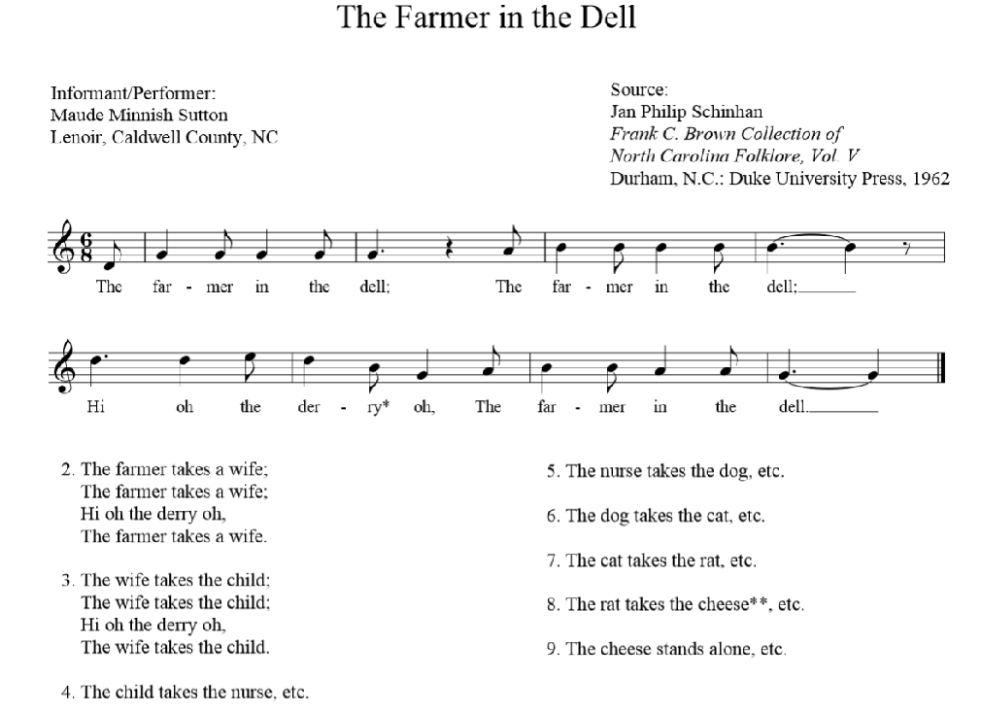
“The Farmer in the Dell” is a wonderful American folk song. This is an easy way to get students to begin exploring culture right here in America. Most often, American folk music will tell stories about daily life when the country was first beginning. Starting with music that is familiar and at the heart of many of our students’ culture is a great way to get them to start shifting their thinking towards customs.
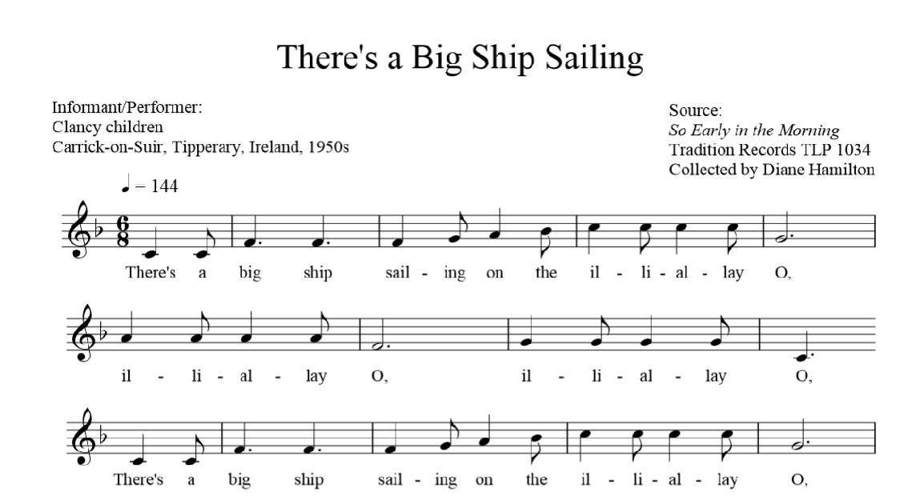
“There’s a Big Ship Sailing” comes from Ireland. Just like “The Farmer in the Dell,” this song can be used to open students up to the music of Ireland. While this does not necessarily need to be the only music from Ireland presented, it is a great way to get students exposed. This would also be an opportunity to begin talking about instrument origins, such as the fiddle from Ireland. Almost always in Irish folk music, there would be one solo voice accompanied by fiddle. Though the fiddle which was used during these times has faded, the style has lived on and continues to be popular today.
Another opportunity with this folk music lies in the ability to discuss how many of the European countries influenced each other with their music. Throughout history, there has been a lot of sharing in music throughout England, Ireland, France, Germany, Italy, and Wales. While other countries contributed to each other’s musical developments, these countries were instrumental in the way the surrounding countries evolved their folk music.
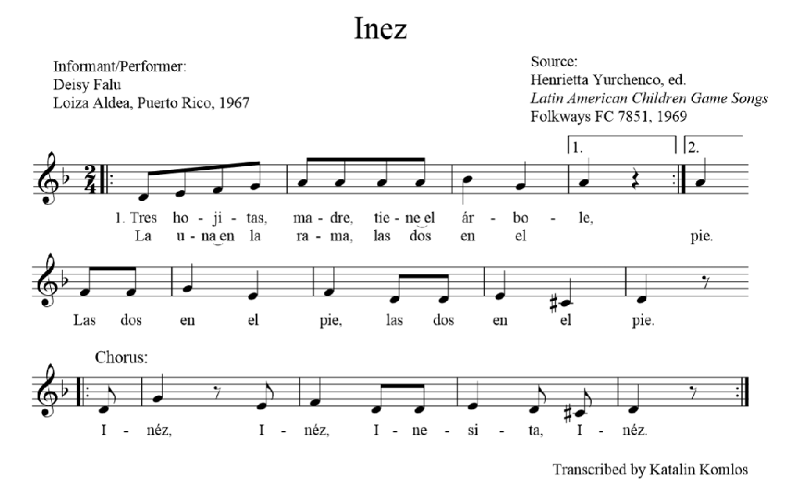
Spanish folk music such as “Inez” from Puerto Rico is a very different style of folk music. Spanish lullabies above all have become well known today. “A la Nanita Nana” is another Spanish folk song that many people find familiar. By introducing this folk music to the classroom, students will have a better understanding of music from Latin countries and the style that is expressed through that music.
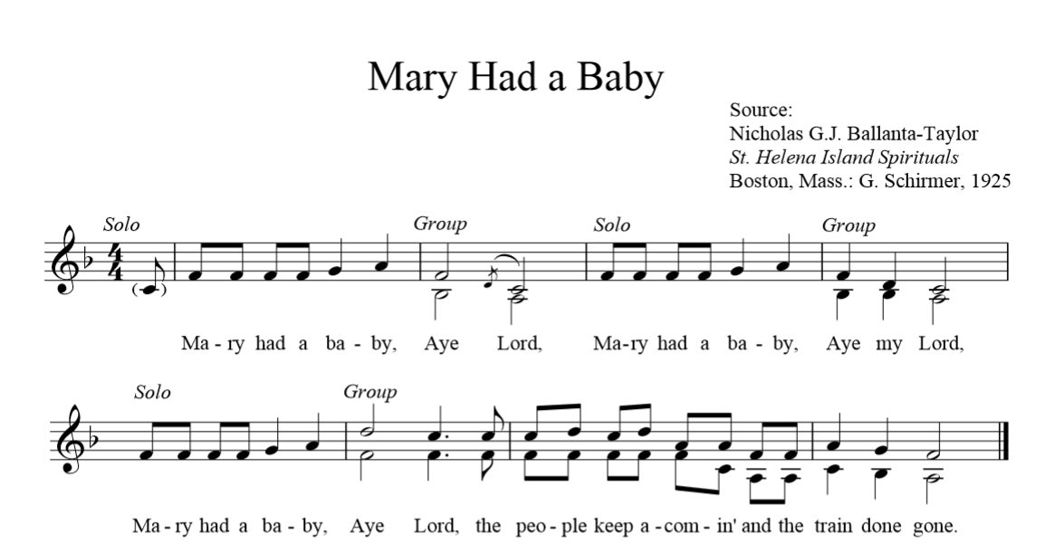
African folk music is often very spiritual in form and text. “Mary Had a Baby” is a very popular folk song of African origin and has been adapted, arranged, and rewritten for many vocal ensemble types. This version in its simplest form is a fun way to get students engaged in the deep, emotional music of Africa.
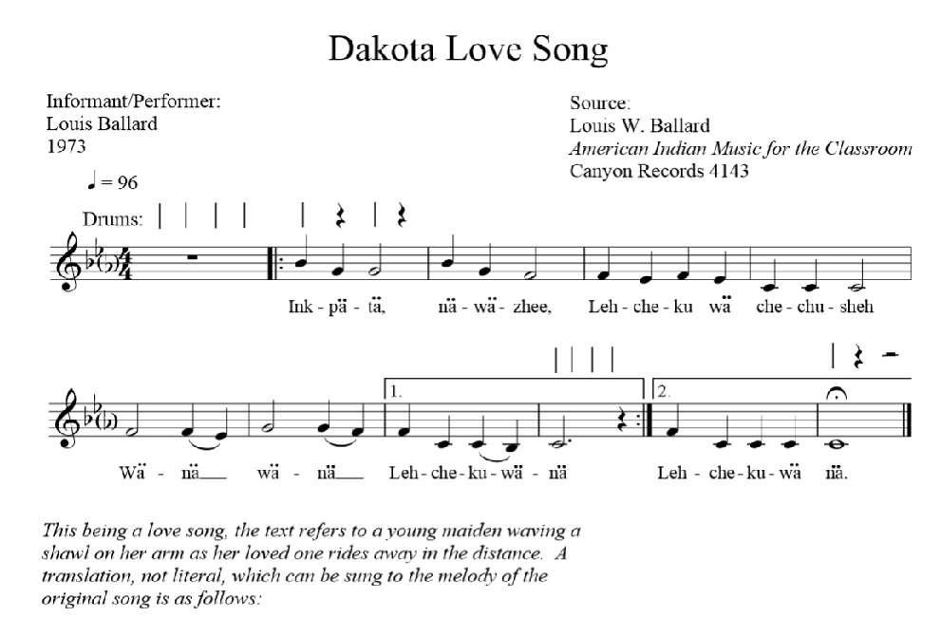
Another style of music that sometimes goes without much thought is the music of the Native Americans. Percussion, in both African music and Native American music, is integral and helps set a tone for the music. There are many Native American folk songs, and they are a great way to connect with students about culture.
Each of these folk songs is not fit for one specific grade level. In fact, it wouldn’t be very helpful to program all of them at once and be done with one presentation. Instead, folk songs and their origins should be layered throughout the library of music that the students receive throughout their elementary education. Time can be taken when each song comes up to discuss origin, culture, and any other songs of similar origin that may have come up earlier in the curriculum. By doing this, when students leave the classroom after so many years, they leave with a basic understanding of folk music from around the world.
Each of the folk songs above was found in the “Organization of American Kodaly Educators” library. This library of folk songs is open to members and music educators to help branch out in folk music from around the world. Zoltan Kodaly spent his life searching for native folk music and organizing it in a way that music educators would be able to share it with the world.

